**STEPS TO REBUILD SQL SERVER – SQL2000**

Shutdown SQL Server and then run Rebuildm.exe located in the “C:\Program Files\Microsoft SQL Server\80\Tools\Binn” directory

**Screen cap 1**

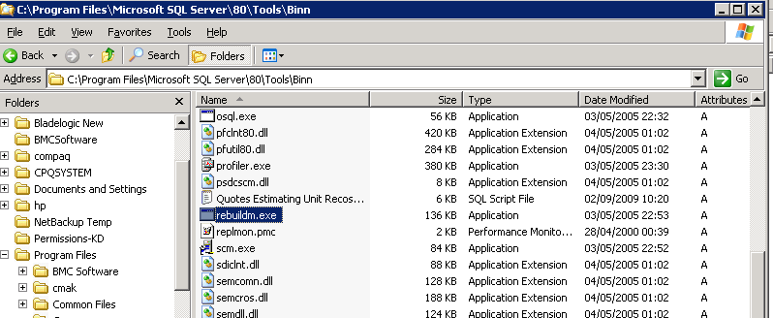

In the Rebuild Master dialog box, select the SQL instance which needs to be rebuilt.

**Screen cap 2**

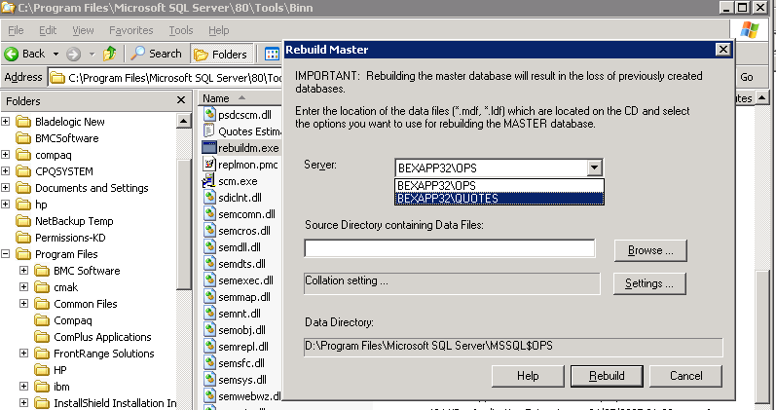

Browse and select the Data folder on the SQL Server 2000 compact disc or in the shared network directory from which SQL Server 2000 was installed**. (Screen cap 3 & 4)**

**Screen cap 3**

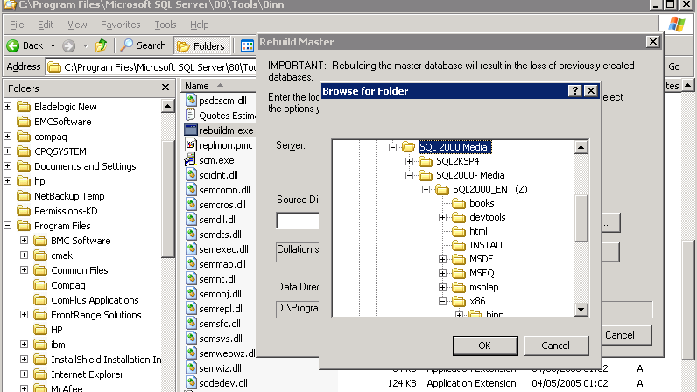

**Screen cap 4**

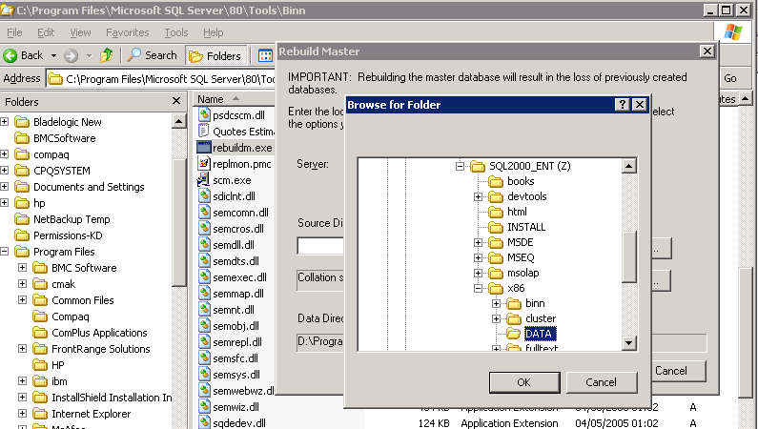

In the Collation Settings dialog box, verify the settings used for the master database and all other databases. (Leave default)

**Screen cap 5**

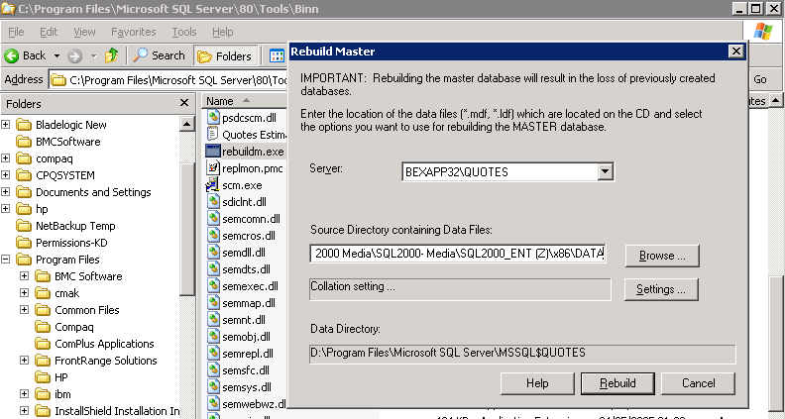

Click **YES** on Rebuild Master dialog box to start the process

**Screen cap 6**

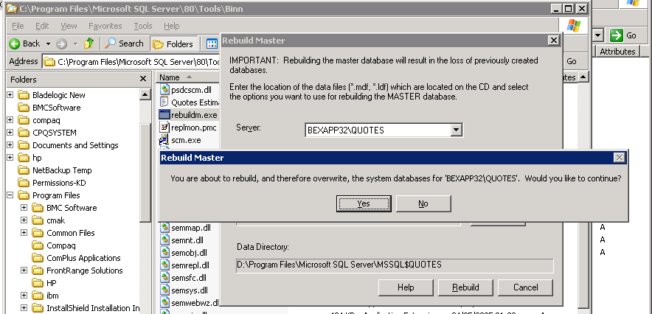

The Rebuild Master utility reinstalls the master database **(Screen cap 7 & 8)**

**Screen cap 7**

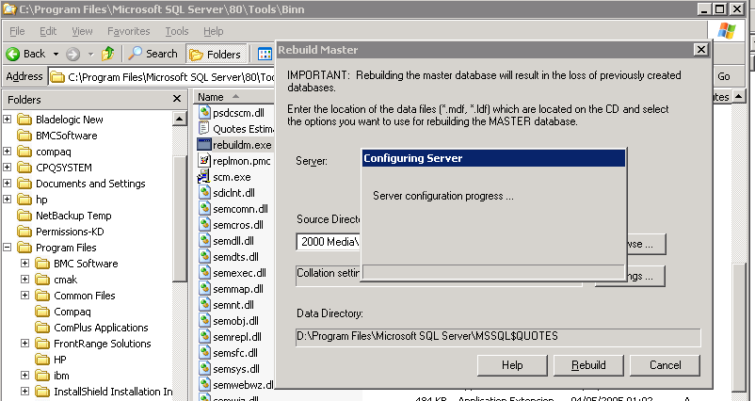

**Screen cap 8**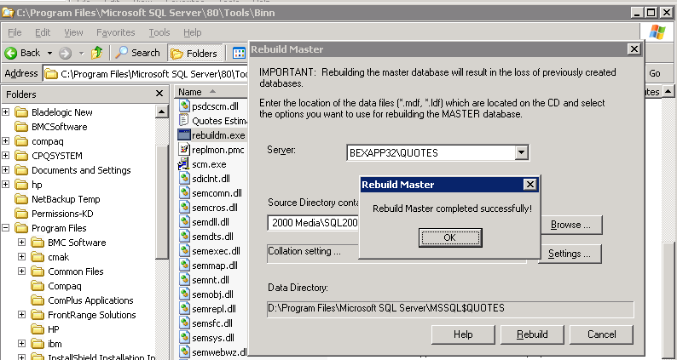

Click OK to complete the master database rebuild

**STEPS TO RESTORE MASTER DATABSE FROM BACKUP**

**Restart SQL Server in single-user mode (Screen cap 9)**

1. Open a command prompt and switch to the path

“D:\Program Files\Microsoft SQL Server\MSSQL$QUOTES\binn” directory.

Issue the following command: **sqlservr.exe –c –m –s quotes** *(Leave the command prompt open )*

**Screen cap 9**

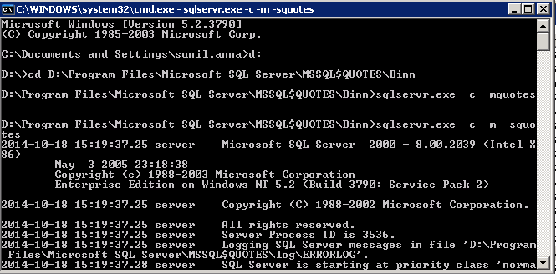

Restore the master database using Query Analyzer from the most recent backup

**Screen cap 10**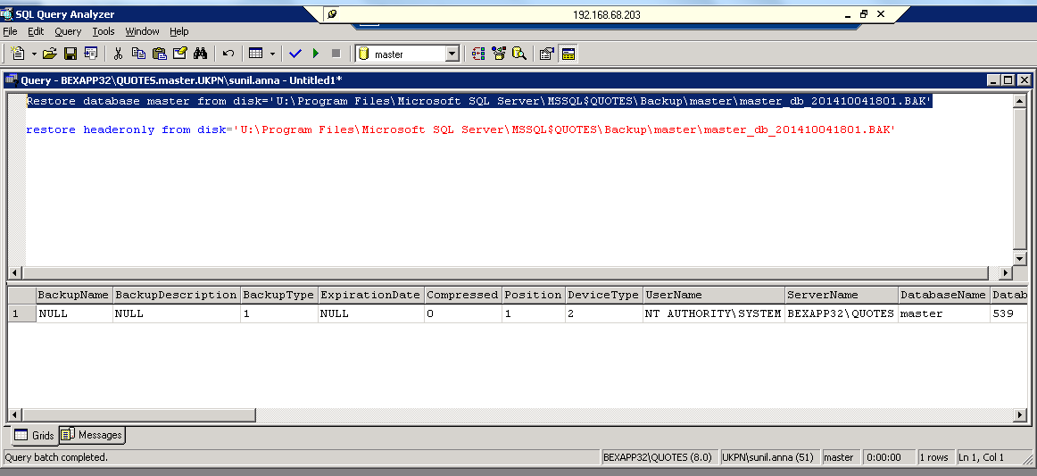

After successfully restoring MASTER database.

Stop the SQL Server service (MSSQL$QUOTES)

On the services list, Right Click on MSSQL$QUOTES and select properties

Remove “-m” from startup parameter column and click on OK to close the properties tab

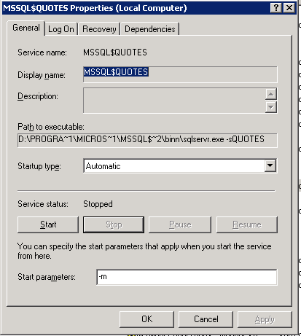

Go to Command prompt

Issue the following command: **NETSTART MSSQL$Quotes /T3608**

**Screen cap 11**

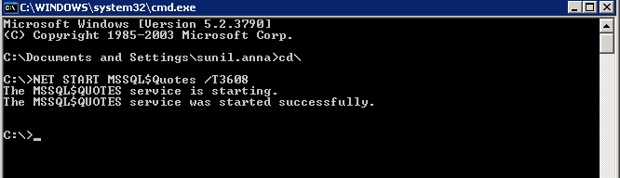

Restore the MSDB, MODEL and User databases using Query Analyzer from the most recent backup

**Screen cap 12**

